Lab 8 Deliverables

Dylan Cauwels and Andrew Han

# Hand Drawn Circuit

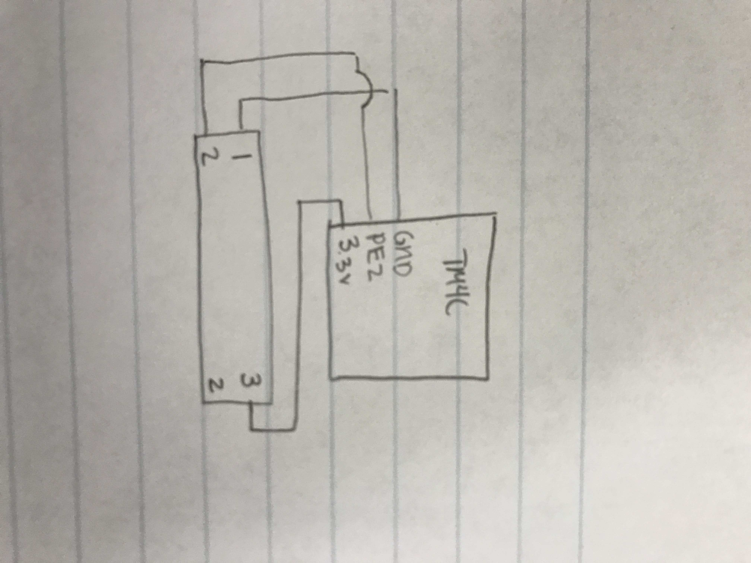

# Calibration Data

# 40Hz Screenshot

# Time Measurement

|  |  |  |  |  |  |  |
| --- | --- | --- | --- | --- | --- | --- |
| position |  | fifo3 |  | ADC sample | position (mm) | analog input |
| 0cm |  |  |  | 0 | 2 | .1 mV |
| .5cm |  |  |  | 340 | 5 | .293V |
| 1cm |  |  |  | 1500 | 10 | 1.216V |
| 1.5cm |  |  |  | 2790 | 15 | 2.17V |
| 2cm |  |  |  | 4000 | 20 | 3.18V |
| 2.2cm |  |  |  | 4095 | 22 | 3.29V |

# Code